Retail Customer Shopping Behavior
& Trends Analysis
An End-to-End Data Analytics Project
Python • SQL • Power BI

Prepared by: Lubdha Desale
Computer Science & Engineering, D.Y. Patil International University
June 2026

1. Executive Summary
This project analyzes a retail company's consumer shopping dataset of 3,900 transactions to answer a core business question: how the company can leverage shopping data to identify trends, improve customer engagement, and optimize marketing and product strategy. The analysis follows a complete, company-style data analytics workflow: data cleaning and feature engineering in Python, relational modeling and business-question querying in SQL, and an interactive four-page dashboard in Power BI.
The headline findings are:
- Online is the dominant channel, generating roughly 3.6x the revenue of Offline (₹182,573 vs ₹50,508), with Clothing the top-selling category on both channels.
- Discounts and promo codes show almost no measurable effect on average order value or review rating in this dataset — average order value is nearly identical whether a discount was applied or not (₹60.13 vs ₹59.28).
- Subscription status is only weakly linked to repeat-purchase behavior (26.1 vs 25.1 average previous purchases for subscribed vs non-subscribed customers) — a smaller effect than typically assumed.
- High-value customers (top 20% by a composite value score) skew slightly older, have nearly 60% more previous purchases on average (36.1 vs 22.7), and spend 67% more per order (₹88.09 vs ₹52.66) than other customers.
- Review ratings are fairly uniform across categories (3.72–3.79) and purchase frequency bands (3.71–3.79), suggesting satisfaction is not a strong differentiator of loyalty in this dataset — other factors are driving repeat behavior.
These findings point to a central recommendation: the company's current discount- and subscription-driven retention levers are not where the real loyalty signal lives. Marketing spend would be better targeted at the behavioral profile of existing high-value customers (purchase history and order value) rather than broad discounting.

2. Problem Statement
A leading retail company wants to better understand its customers' shopping behavior in order to improve sales, customer satisfaction, and long-term loyalty. The management team has noticed changes in purchasing patterns across demographics, product categories, and sales channels (online vs. offline), and is particularly interested in uncovering which factors — such as discounts, reviews, seasons, or payment preferences — drive consumer decisions and repeat purchases.
The overarching business question addressed by this project is:
“How can the company leverage consumer shopping data to identify trends, improve customer engagement, and optimize marketing and product strategies?”

3. Methodology
The project follows a five-stage, company-style analytics workflow:

3.1 Data Preparation & Modeling (Python)
The raw dataset (3,900 rows, 18 columns) was cleaned and enriched in Python using pandas:
- Column names standardized to snake_case for downstream SQL compatibility.
- 37 missing review_rating values imputed using the category-wise median rather than a global average, since ratings vary meaningfully by product category.
- Duplicate-row check performed (none found).
- A purchase_date field was simulated, since the raw data only carried a season label rather than a real date. Each row was assigned a random date drawn from its corresponding seasonal window across 2023, enabling genuine time-series analysis in later stages.
- A sales_channel field (Online / Offline) was simulated using shipping-type logic — Store Pickup orders were treated as Offline, with 8% random noise added to avoid an unrealistically clean split — since the raw data did not include a channel column.
- Feature engineering added: age_group brackets, binary flags for subscription/discount/promo status, a composite customer_value_score (purchase amount scaled by purchase history), and a high_value_customer flag for the top 20% of customers by that score.
Output: cleaned_customer_shopping_data.csv (3,900 rows, 26 columns), used as the single source feeding both the SQL and Power BI stages.

3.2 Data Analysis (SQL)
The cleaned dataset was normalized into a star schema and loaded into a SQLite database for structured querying:
- dim_customers — one row per customer (demographics, value score, subscription status).
- dim_products — one row per unique item/category combination.
- fact_transactions — one row per purchase transaction, linked to both dimension tables by foreign key.
Fourteen analysis queries were written across four sections — Channel Performance, Customer Segments, Loyalty & Repeat-Purchase Drivers, and Purchase Drivers — directly answering the business questions in the brief. Full query text is included in analysis_queries.sql in the project repository.

3.3 Visualization & Insights (Power BI)
An interactive four-page Power BI dashboard was built on top of the same three tables, connected via the customer_id and product_id relationships:
- Overview — KPI cards (Total Revenue, Total Orders, Avg Order Value, Avg Review Rating), a monthly revenue trend line, and an Online vs Offline channel donut chart, with season, channel, and category slicers.
- Customer Segments — spend by age group and gender, top 10 locations by revenue, and a high-value customer profile table.
- Loyalty & Drivers — subscription vs. previous purchases, purchase frequency vs. review rating, and a subscription × discount matrix.
- Purchase Drivers — discount/promo impact on order value and rating, review rating by category, and payment method preference split by customer value tier.

3.3a Dashboard Screenshots
The four completed Power BI dashboard pages are shown below, built directly on the cleaned dataset and SQL-derived tables described in this report.

Page 1 — Overview
Total revenue ($233K), average order value ($59.76), average review rating (3.75), and total orders (4,000) are shown as headline KPIs, alongside the monthly revenue trend, the Online vs. Offline channel split (78.3% Online), and revenue by category.
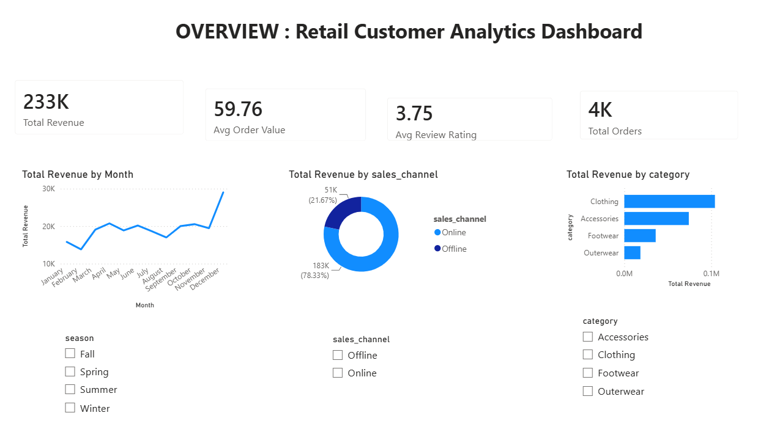
Figure 1. Overview page — KPIs, monthly trend, channel split, and category revenue.

Page 2 — Customer Segments
Revenue by age group and gender, the top-revenue locations, and the high-value customer profile summary (20% high-value share, 25.35 average previous purchases, $59.76 average order value, 27% subscriber rate).
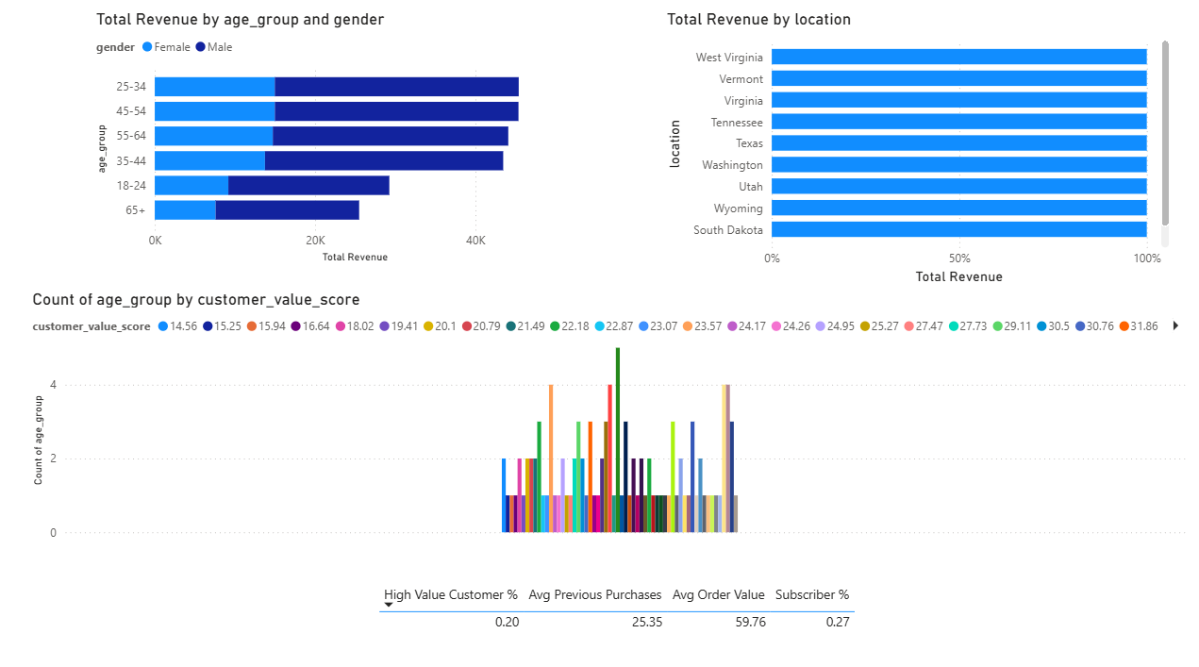
Figure 2. Customer Segments page — demographic and geographic revenue breakdown.

Page 3 — Loyalty & Drivers
Average previous purchases by subscription status (25.08 vs. 26.08 — confirming the marginal difference discussed in Section 5.3), total orders by purchase frequency, and average review rating by frequency band, which stays tightly clustered between 3.71 and 3.78 regardless of how often a customer buys.
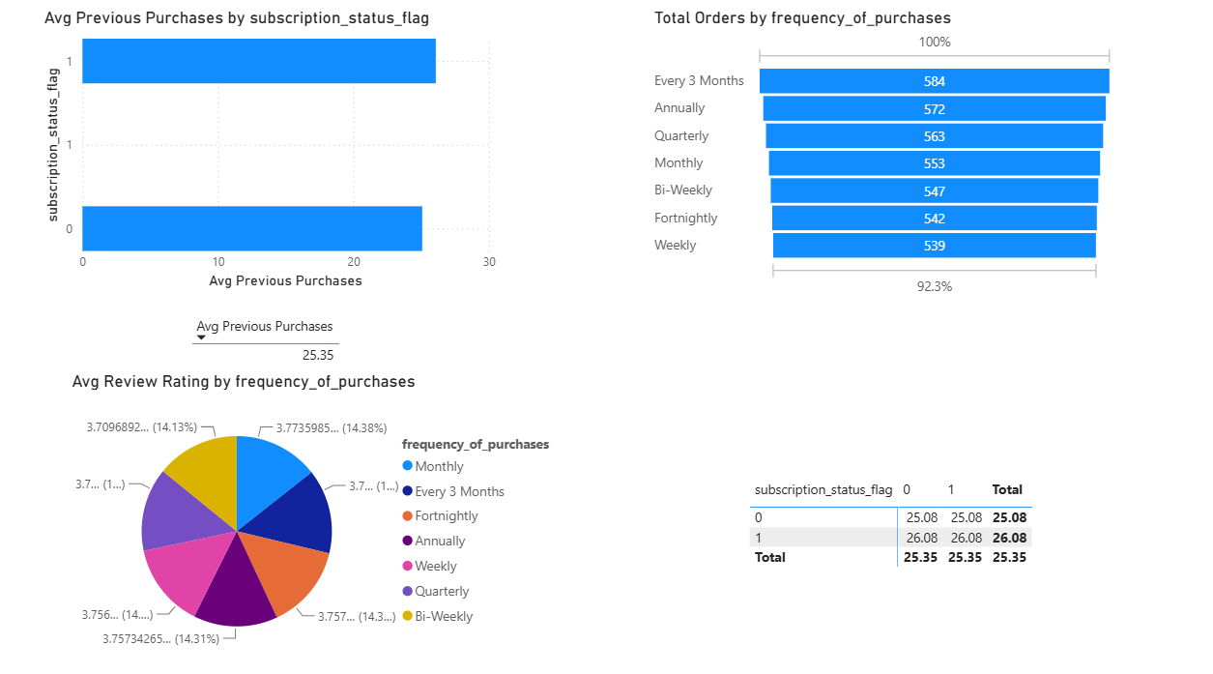
Figure 3. Loyalty & Drivers page — subscription, frequency, and rating relationships.

Page 4 — Purchase Drivers
Average order value and review rating split by discount usage (visually near-identical bars, confirming the negligible effect of discounting), review rating by category, and order distribution by payment method split by high-value customer status — again showing minimal variation across payment types.
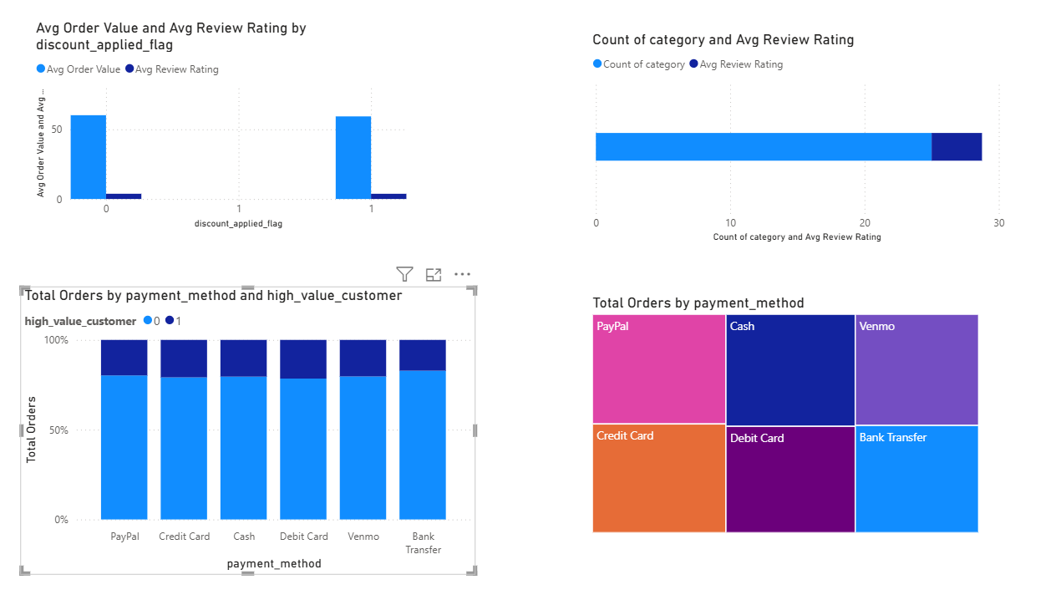
Figure 4. Purchase Drivers page — discount impact, category ratings, and payment method mix.

3.4 Report & Presentation
This report and an accompanying slide presentation summarize the key findings and translate them into business recommendations for stakeholders.

3.5 GitHub Repository
All Python scripts, the SQL schema and queries, the cleaned dataset, the Power BI export files, and this report are organized in a structured GitHub repository for portfolio purposes.

4. Data Overview
After cleaning, the dataset comprises 3,900 transactions across 25 unique products in 4 categories (Clothing, Accessories, Footwear, Outerwear), purchased by customers aged 18–70 across all 50 US states, with purchase amounts ranging from approximately $20 to $100.

4.1 Channel Split
Sales Channel | Orders | Total Revenue | Avg Order Value | Avg Review Rating
Online | 3,069 | $182,573 | $59.49 | 3.76
Offline | 831 | $50,508 | $60.78 | 3.72
Table 1. Order volume and revenue by sales channel.

5. Key Findings

5.1 Channel Performance
Online accounts for 78.7% of orders and 78.3% of revenue, generating roughly 3.6x the revenue of Offline. Clothing is the top category on both channels by a wide margin, followed by Accessories, Footwear, and Outerwear in the same order — the category ranking is consistent regardless of channel, suggesting channel choice does not change what customers buy, only how they buy it.
Channel | Category | Units Sold | Revenue
Online | Clothing | 1,353 | $81,219
Online | Accessories | 975 | $58,152
Online | Footwear | 483 | $28,953
Online | Outerwear | 258 | $14,249
Offline | Clothing | 384 | $23,045
Offline | Accessories | 265 | $16,048
Offline | Footwear | 116 | $7,140
Offline | Outerwear | 66 | $4,275
Table 2. Category performance split by sales channel.

5.2 Customer Segments
Spend is fairly evenly distributed across age groups and gender, with no segment standing out as dramatically higher-spending — average order value sits in a narrow $57.82–$62.13 band across all twelve age/gender combinations. This suggests demographic targeting alone is unlikely to meaningfully shift revenue; behavioral segmentation (covered below) is more informative.
Revenue is also broadly distributed geographically, with the top 10 states (Montana, Illinois, California, Idaho, Nevada, Alabama, New York, North Dakota, West Virginia, Nebraska) each contributing $5,000–$5,800 — no single region dominates.
The high-value segment (top 20% of customers by composite value score, 782 customers) shows a clearer pattern:
Segment | Customers | Avg Age | Avg Previous Purchases | Avg Order Value | % Subscribed
High-Value (top 20%) | 782 | 45.0 | 36.1 | $88.09 | 27.7%
Other Customers | 3,118 | 43.8 | 22.7 | $52.66 | 26.8%
Table 3. Profile comparison: high-value vs. other customers.
High-value customers buy more per order and have substantially more purchase history, but are barely more likely to hold a subscription (27.7% vs 26.8%) — reinforcing that subscription status is not the driver of value it might be assumed to be.

5.3 Loyalty & Repeat-Purchase Drivers
This was the most counter-intuitive finding of the analysis. Subscribed customers average only 1 more previous purchase than non-subscribed customers (26.1 vs 25.1) — a marginal difference that does not support subscription status as a strong loyalty indicator in this dataset.
Purchase frequency also shows almost no relationship with review rating (3.71–3.77 across all seven frequency bands, from Bi-Weekly to Annually) or with previous-purchase count (24.6–26.9 across the same bands). In other words, customers who buy weekly are not meaningfully more satisfied, nor do they have a longer purchase history, than customers who buy annually — frequency of purchase appears to be more a function of product category / replenishment need than of loyalty or satisfaction.

5.4 Purchase Drivers
Discounts and promo codes show negligible impact: orders without a discount average $60.13 with a 3.76 rating, while discounted/promo orders average $59.28 with a 3.74 rating — a difference small enough to be noise rather than a meaningful effect. This suggests the company's current discounting strategy is not the lever driving order value or satisfaction.
Seasonality is similarly flat — Fall, Spring, and Winter each contribute roughly $58,600–$60,000 in revenue, with Summer slightly lower at $55,777. No single season represents an outsized opportunity or risk.
Review ratings by category are also narrow (3.72 for Clothing to 3.79 for Footwear), meaning no category is dramatically underperforming on satisfaction relative to the others.
Payment method preference is evenly split across all six methods (Credit Card, Debit Card, Cash, PayPal, Venmo, Bank Transfer) for both high-value and other customers, with no method showing a meaningful skew toward either segment — payment method does not appear to be a useful targeting variable.

6. Business Recommendations
- Double down on Online, but don't abandon Offline category mix. Since Online already drives 3.6x Offline revenue with an identical category ranking, marketing budget is best weighted toward Online acquisition and retention campaigns. Offline's slightly higher average order value ($60.78 vs $59.49) suggests in-store/pickup customers may respond well to upsell prompts at checkout.
- Re-evaluate the discount and promo strategy. Since discounted orders show no meaningful lift in order value or satisfaction, blanket discounting is likely an avoidable cost. Recommend A/B testing targeted, smaller discounts on specific high-margin SKUs rather than broad promo codes.
- Shift loyalty-program design away from subscription status and toward purchase history. Since previous-purchase count (not subscription status) is what actually separates high-value from other customers, retention programs should reward cumulative purchase behavior (e.g. tiered rewards based on lifetime orders) rather than a binary subscribe/don't-subscribe model.
- Build a behavioral, not demographic, targeting model. Since age, gender, and location show minimal spend variation, marketing segmentation should prioritize the customer_value_score (order value × purchase history) used in this analysis over standard demographic buckets.
- Investigate the Footwear category as a satisfaction benchmark. Footwear has both the highest average review rating (3.79) and a competitive average order value ($60.26) — worth a follow-up qualitative study to understand what's driving that satisfaction and whether it's replicable in Clothing, the largest but lowest-rated category.
- Treat purchase frequency as an operational signal, not a loyalty signal. Since frequency bands show flat satisfaction and purchase history, frequency data is more useful for inventory/replenishment planning than for identifying which customers to prioritize for retention spend.

7. Conclusion
This analysis demonstrates that several commonly assumed loyalty drivers in retail — subscriptions, discounts, and purchase frequency — show only a weak relationship with actual customer value in this dataset. The strongest, most consistent signal of a high-value customer is straightforward: order value and purchase history. This reframes the company's strategic question from 'how do we get more people to subscribe or use discounts' to 'how do we identify and nurture customers who already show high order value and purchase frequency, regardless of subscription status.'
The complete technical workflow — from raw CSV to cleaned dataset, relational SQL model, and interactive Power BI dashboard — is available in the accompanying GitHub repository, along with all source code, the SQL schema and queries, and the dashboard export.

8. Appendix: Project Artifacts
- data/raw_customer_shopping_behavior.csv — original raw dataset
- python/data_preparation.py — Python cleaning & feature engineering script
- python/data_preparation_colab.ipynb — Google Colab notebook version
- data/cleaned_customer_shopping_data.csv — cleaned, enriched dataset
- sql/schema.sql — star-schema table definitions
- sql/build_database.py — script to load cleaned data into SQLite
- sql/analysis_queries.sql — 14 business-question SQL queries
- sql/retail.db — SQLite database file
- powerbi/dim_customers.csv, dim_products.csv, fact_transactions.csv — Power BI source tables
- powerbi/POWER_BI_GUIDE.md — dashboard build guide (relationships, DAX measures, visuals)
- retail_dashboard.pbix — final Power BI dashboard file
- images/ — exported dashboard page screenshots (Overview, Customer Segments, Loyalty & Drivers, Purchase Drivers)
- Project_Report.docx — this report

